**Sprint** 3 **-** Agility **Design Document**

December 4**, 20**23

**Table of Contents**

**1.** **EXECUTIVE SUMMARY 3**

1.1 Project Overview 3

1.2 Purpose and Scope of this Specification 3

**2.** **PRODUCT/SERVICE DESCRIPTION 3**

2.1 Product Context 3

2.2 User Characteristics 3

2.3 Assumptions 3

2.4 Constraints 3

2.5 Dependencies 4

**3.** **REQUIREMENTS 4**

3.1 Functional Requirements 5

3.2 Security 5

*3.2.1* *Protection 5*

*3.2.2* *Authorization and Authentication 6*

3.3 Portability 6

**4.** **REQUIREMENTS CONFIRMATION/STAKEHOLDER SIGN-OFF 6**

**5.** **SYSTEM DESIGN 6**

5.1 Algorithm 6

5.2 System Flow 6

5.3 Software 6

5.4 Hardware 6

5.5 Test Plan 7

5.6 Task List/Gantt Chart 7

5.7 Staffing Plan 7

# Executive Summary

## ***Project Overview***

This project is split into 4 parts- agility being the 3rd. The course will start in a square. Then the robot will encounter 3 objects which it must avoid.. Next, the robot will go over the ramp. Finally, the robot will know over as many pins as possible. Points added for each obstacle the robot completes, for each obstacle avoided and, for each pin the robot topples.

## ***Purpose and Scope of this Specification***

This document addresses requirements related to phase 3 of our CS final:

* Accuracy
* Agility
* Repetition
* Precision

# Product/Service Description

This project requires our robot to travel through an obstacle course. Some possible factors that may affect or challenge us in the completion of this project are how the robot glides after we code it to stop moving, how to maneuver the angles, speed, and timing of the block code, any dirt or obstacles in the way that may knock our robot ff its path, and the trial and error in getting our robot to precisely topple the pins and maneuver through the course.

## ***Product Context***

This product relates to automobiles in the way that they both move, though they are different because our product is coded and small, and cars are user operated and large. This product relates to a computer in the way that they both use code to operate, though they are different because our product is coded to move, and computers are coded for a multitude of reasons, but they are not able to move.

## ***User Characteristics***

1. Student
   1. in a computer science class
   2. has a computer
2. Teacher
   1. teaching the computer science class
   2. has a computer

## ***Assumptions***

In order to use this product, you would need to have a Sphero SPRK+ robot, a computer or phone that can run Sphero EDU, and access to room HH208. That can be checked on the MyMU.

## ***Constraints***

This design may not work if you do not have…

* the current version of Sphero EDU downloaded on your device
* access to room HH208
* a Sphero SPRK+ robot
* an obstacle course
* a correct orientation of your robot
* a working computer with a lot of disc space

The obstacle course had odd metrics and needed to be coded to the specific metrics of the classroom the obstacle course was made for

## ***Dependencies***

This product will need…

* the current version of Sphero EDU downloaded on your device
* access to room HH208
* a Sphero SPRK+ robot
* an obstacle course
* a correct orientation of your robot
* a working computer with a lot of disc space

# Requirements

* Start in the provided square
* Maneuver around the obstacles in the obstacle course
* Conquer the incline
* Knock over pins

## ***Functional Requirements***

| **Req#** | **Requirement** | **Comments** | **Priority** | **Date Rvwd** | **SME Reviewed / Approved** |
| --- | --- | --- | --- | --- | --- |
| AGILITY_01 | Start in the provided square | Easy | 1 | 12/3 | 12/3 |
| AGILITY_02 | Maneuver around the obstacles in the obstacle course | Difficult | 1 | 12/3 | 12/3 |
| AGILITY_03 | Conquer the incline | Difficult | 1 | 12/3 | 12/3 |
| AGILITY_04 | Knock over pins | Easy | 1 | 12/3 | 12/3 |

## ***Security***

### **Protection**

The computer used should have a password in order to keep the code secured. The robot should be in possession of the students at all times so it does not get lost or stolen.

### **Authorization and Authentication**

The computer will have to be logged on by one of the students/team members.

## ***Portability***

All of the parts are relatively portable. The computer can be a laptop which you can carry around, and the robot is small enough to fit in a backpack. You just can’t take room HH208 with you.

# Requirements Confirmation/Stakeholder sign-off

| **Meeting Date** | **Attendees (name and role)** | **Comments** |
| --- | --- | --- |
| 12/3/2023 | Lynda, Kevin, Chris | 4th meeting outside of class (sprint 3) |

# System Design

## ***Algorithm***

* Start in the starting square of obstacle course
* Move 3’3 feet forward (avoid obstacle in path)
* Move 3’3 feet to the right (avoid obstacle in path)
* Move 3’10 feet forward (avoid obstacle in path)
* Move 7 feet to the right
* Move 9’1 feet to the right (knock into the pins)

## ***System Flow***

## 

## 

## ***Software***

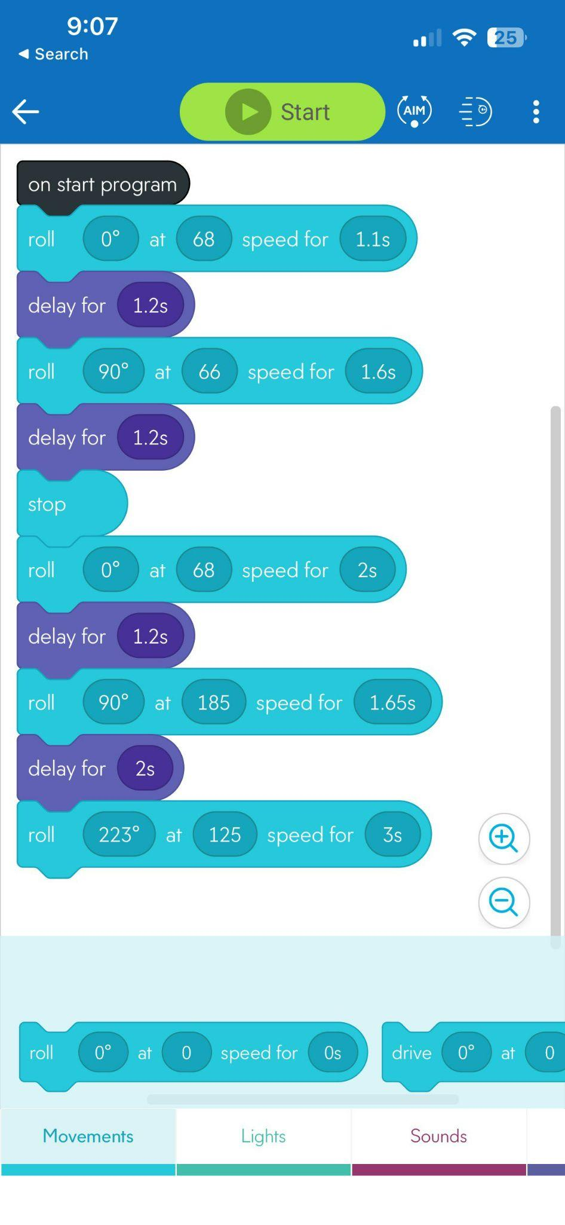

## ***Hardware***

* a Sphero SPRK+ robot
* a working computer with a lot of disc space

## ***Test Plan***

| **Reason for Test Case** | **Test Date** | **Expected Output** | **Observed Output** | **Staff Name** | **Pass/Fail** |
| --- | --- | --- | --- | --- | --- |
| Maneuver the obstacles | 12/3 | it willmove around all the obstacles | knocked into the first obstacle | Lynda, Chris | Fail |
| Maneuver the obstacles | 12/3 | it will move around all the obstacles | knocked into the second obstacle | Lynda, Chris | Fail |
| Maneuver the obstacles | 12/3 | it will move around all the obstacles | knocked into the third obstacle | Lynda, Chris | Fail |
| Maneuver the obstacles | 12/3 | it will move around all the obstacles | moved around all the obstacles | Lynda, Chris | Pass |
| Get over the ramp | 12/3 | it will go over the ramp | it was too slow | Lynda, Chris | Fail |
| Get over the ramp | 12/3 | it will go over the ramp | it got over the ramp | Lynda, Chris | Pass |
| Knock into pins | 12/3 | it will knock over most pins | it knocked over all but 2 pins | Lynda, Chris | Pass |

## 5.6 ***Task List/Gantt Chart***

## 

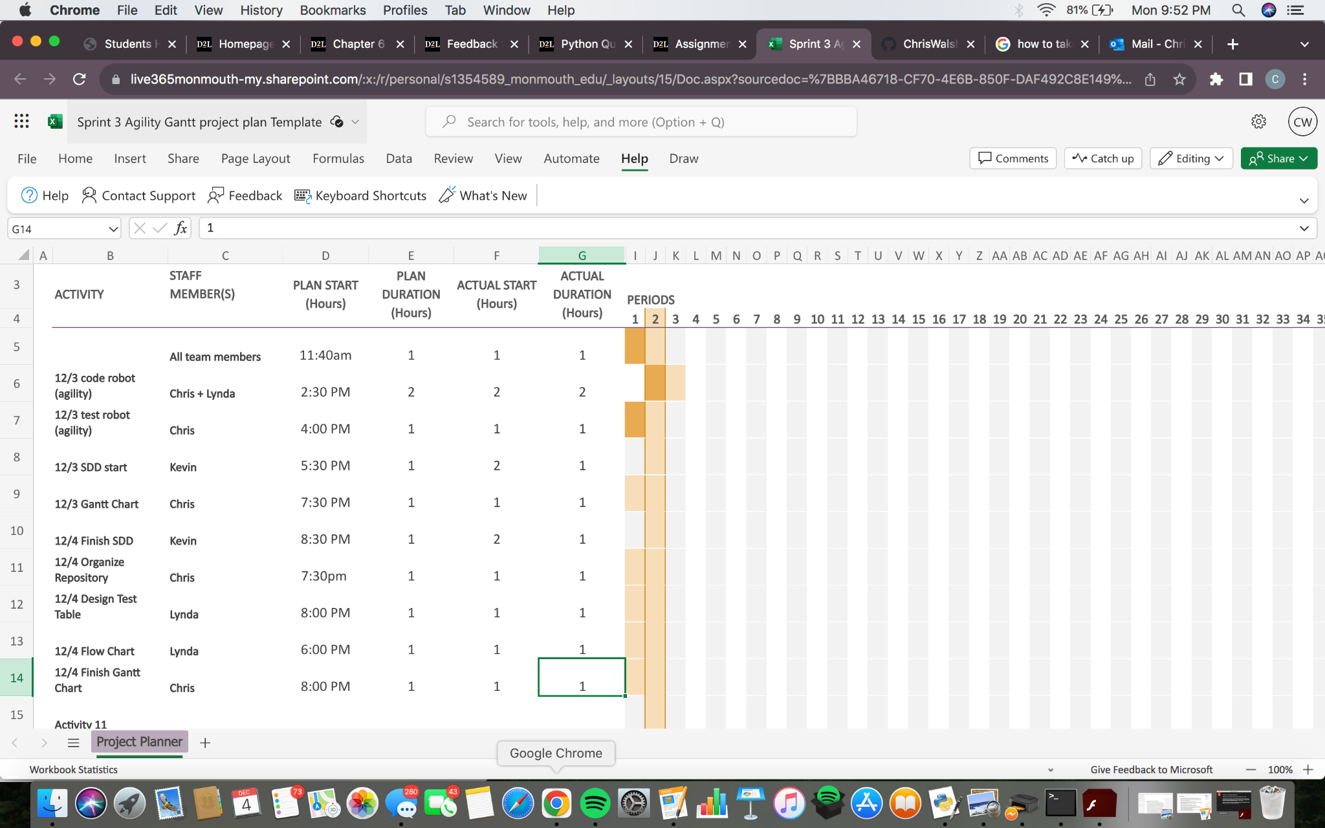

## ***Staffing Plan***

| Name | Role | Responsibility | Reports To |
| --- | --- | --- | --- |
| Chris | Tester | Troubleshooting | Lynda |
| Lynda | Center of data | Puts work into data tables (data entry) | Kevin |
| Kevin | Manager | Make sure everything is on task | Chris |